Name: __________________________  
Date: ___________________________

Lesson 2-7: Surface Area and Volume Quiz Review

**Station Questions**

1. How many square inches of wrapping paper re needed to entirely cover a box that is 4 inches by 5 inches 6 inches?
2. 148 in2 (Go to station 9)
3. 136 in2 (Go to station 10)
4. 148 in3 (Go to station 5)
5. 120 in2 (Go to station 8)

1. What is the total surface area of the following figure?
   1. 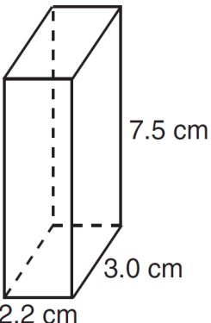91.235 in2 (Go to station 5)
   2. 49.5 cm3 (Go to station 2)
   3. 91.2 cm2 (Go to station 10)
   4. 49.5 cm2 (Go to station 9)

1. 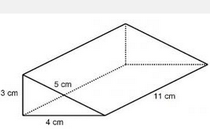What is the volume of the following figure?
   1. 126 cm3 (Go to station 5)
   2. 132 cm3 (Go to station 8)
   3. 66 cm3 (go to station 7)
   4. 120 cm2 (Go to station 2)
2. 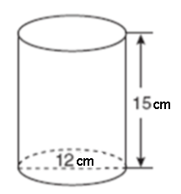A can of Campbell’s chicken noodle soup is shown to the right. The label only covers the curved surface of the can. What is the total area of the soup label rounded to the nearest square centimeter.
   1. 580cm2 (Go to station 3)
   2. 792cm2 (Go to station 7)
   3. 565cm2 (Go to station 1)
   4. 1696cm2 (Go to station 10)

1. 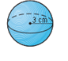What is the total surface area of the following sphere, *in terms of Pi.* 
   1. 36 $π$ (Go to station 7)
   2. 36cm2 (Go to station 3)
   3. 362 (Go to station 5)
   4. 12cm2 (Go to station 1)

1. Find the *lateral surface area* of the give solid. Round your answer to the nearest tenth of a square inch.
   1. 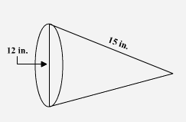282.7 square inches (Go to station 4)
   2. 290.8 square inches (Go to station 5)
   3. 565.5 square inches (Go to station 8)
   4. 674.8 square inches (Go to station 9)
2. When you blow up a balloon it forms a sphere because it is trying to hold as much air as possible with as small a surface as possible. How much air, to the nearest tenth of a cubic inch, is being held by a spherical balloon with a diameter of 12 inches?
   1. 2714.3 cm2 (Go to station 1)
   2. 150.8 square inches (Go to station 2)
   3. 904.8 square inches (Go to station 6)
   4. 904.8 in3 (Go to station 8)

1. 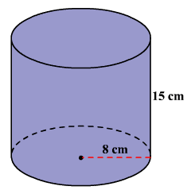Find the surface area of the following figure. Leave your answer in terms of Pi.
   1. 3682 (Go to station 7)
   2. 3682 (Go to station 6)
   3. 2402 (Go to station 8)
   4. 128cm2 (Go to station 9)

1. The volume of a cylinder is 12,566.4 cm3. The height of the cylinder is 8 cm. Find the radius of the cylinder to the *nearest tenth of a centimeter*.
   1. 22.4cm (Go to station 2)
   2. 30.6cm2 (Go to station 1)
   3. 32.0cm (Go to station 7)
   4. 22.4cm2 (Go to station 10)

1. What is the volume of the following three dimensional object?
   1. 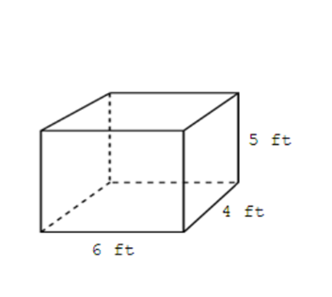120 ft2 (Go to station 1)
   2. 148 ft3 (Go to station 2)
   3. 120 ft3  (Go to station 5)
   4. 220 cubic feet (Go to station 3)